ACL Topology
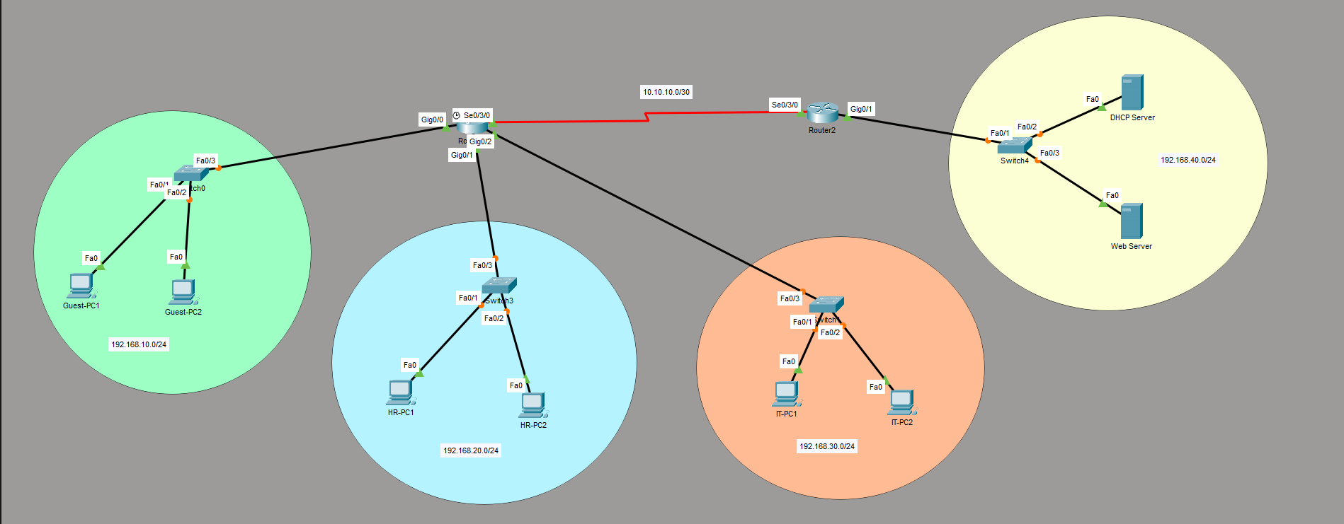

ACL Configuration
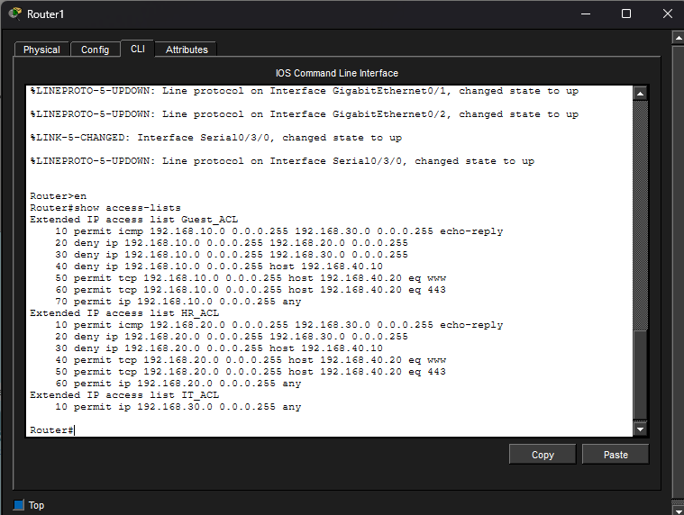

Expected Results
✔ Guests cannot access HR or IT resources.
✔ Guests cannot access the DHCP server.
✔ Guests can browse the Web Server.
✔ HR cannot access the IT network.
✔ HR can access the Web Server.
✔ IT has full network access.

VERIFICATION
Guest PC
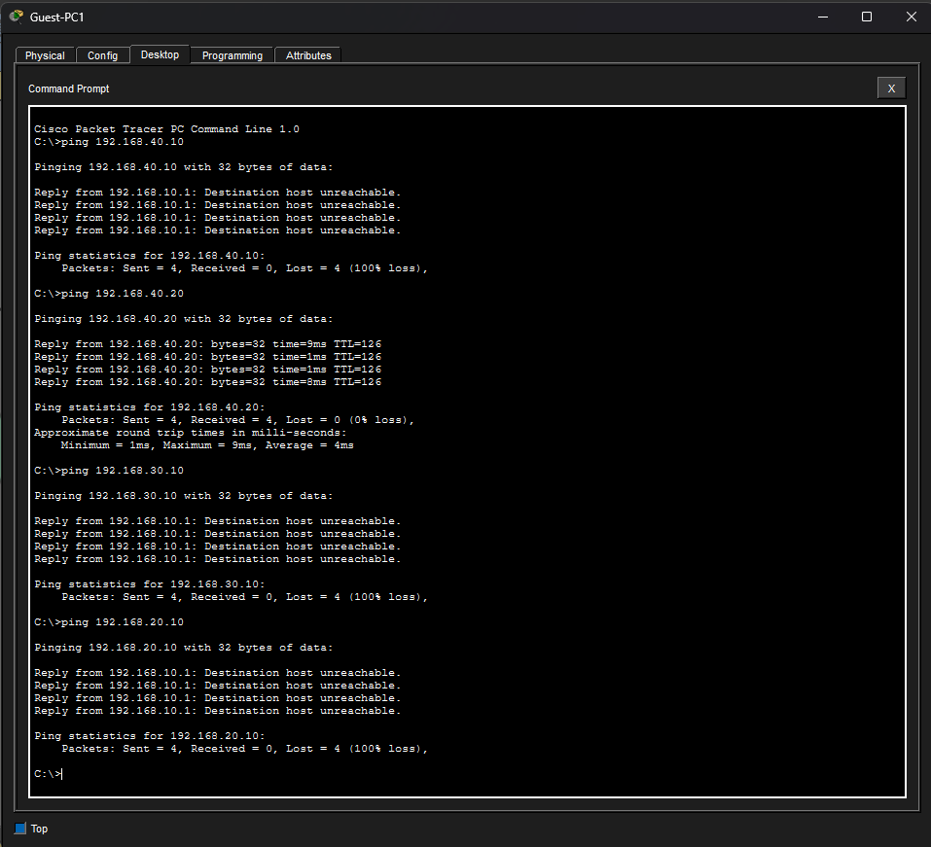
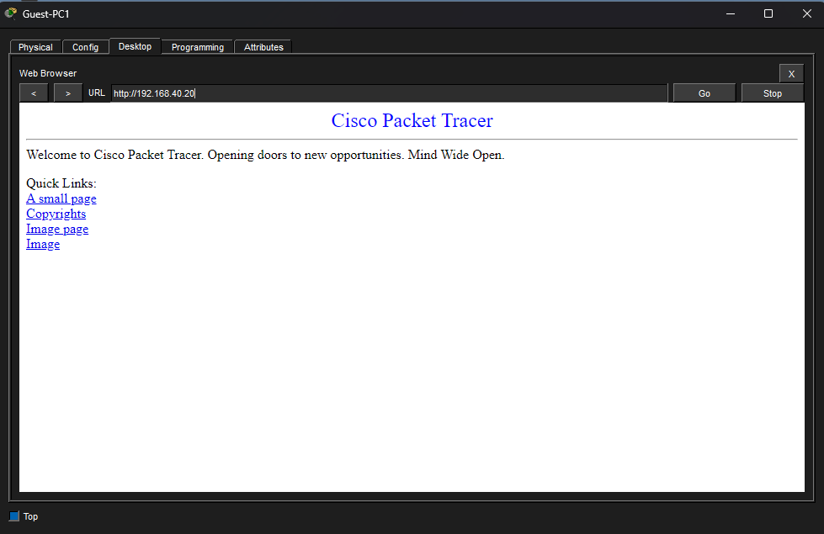
HR PC
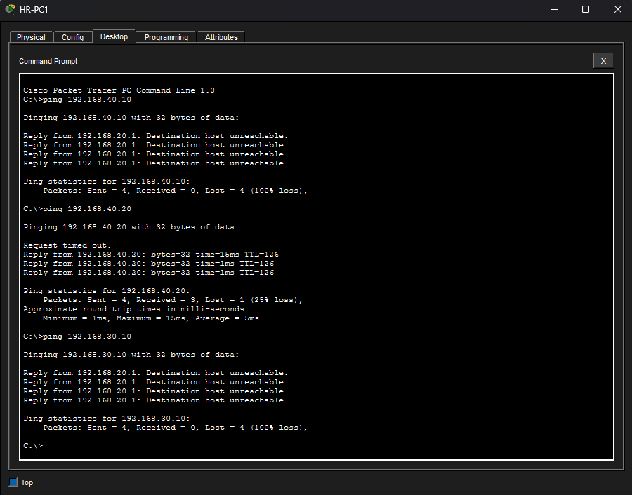
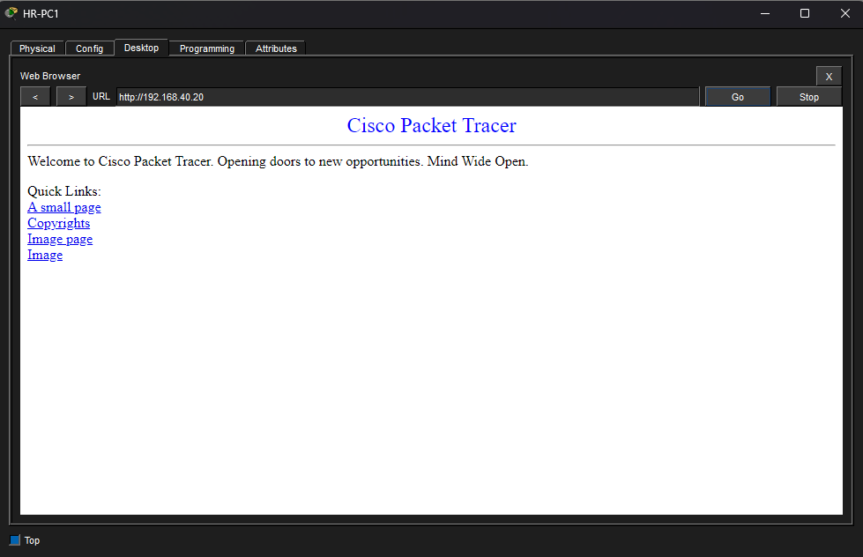
IT PC
